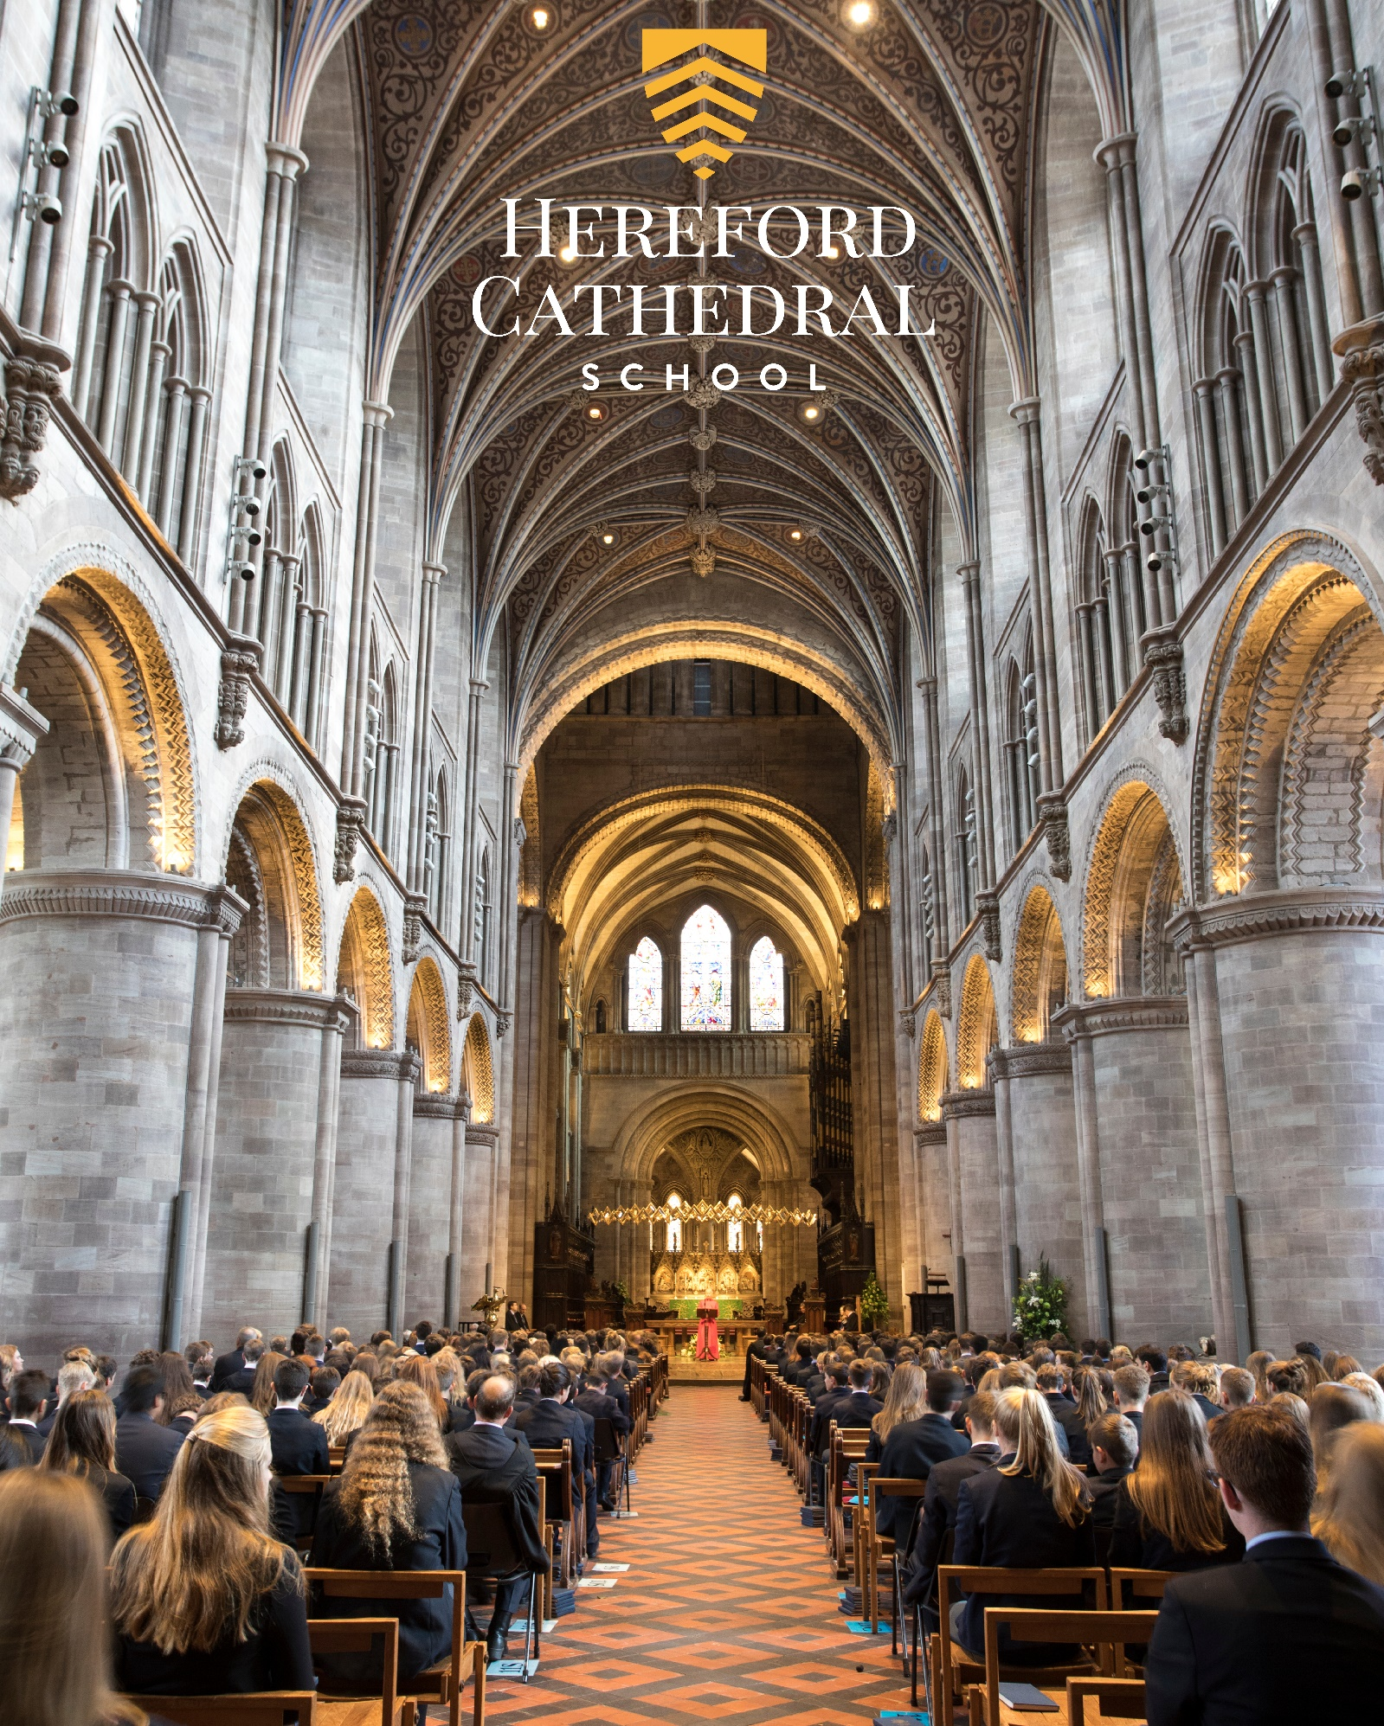

Accountant
Candidate Information Booklet
HEREFORDCS.COM
01432 363522

Welcome
Thank you for your interest in the position of Accountant at Hereford Cathedral School. I hope that this information booklet will help provide you with some insight into our Cathedral School, Hereford city, and the outstanding county in which we are privileged to be located.

From our three year-olds in Nursery to our 18 year-olds in the Sixth Form, we seek to meet the specific needs of every pupil – providing stretch and challenge in the classroom and a wide variety of opportunities to develop individual interests, skills and self-esteem.

Alongside our small class sizes, excellent results and the outstanding range of opportunities on offer, we feel that our greatest strength lies in our friendly, family, inclusive ethos, encouraged by excellent staff pupil relations and a highly supportive parent body. It is this ethos, widely recognised as a special characteristic of the school, which enables pupils, young and old, to excel both in and out of the classroom.

The school is one of the UK’s leading independent co-educational day schools. We also benefit from the finest of settings, adjacent to a beautiful Cathedral and within a stone’s throw of the thriving city centre.

This is an exciting time in the development of the school and the School Accountant will play their part in helping the school as it opens a boarding house and dealing with the political uncertainties that lie ahead. Details of the position, and the qualities that we seek in the successful applicant, are included in the job description.

I hope that the information provided in this pack gives you a sense of what to expect at Hereford Cathedral School and helps you to decide whether this is the right post for you. Please feel free to contact me directly if you have any further questions.

Paul Smith,
Headmaster

“Justifiably growing more self-assured, a school with a great deal to offer and an ethos of careful, thoughtful, nurture. Much to impress, with truly outstanding arts and music, a wide curriculum, a great sense of community service and genuine commitment to developing courage, confidence and a sense of adventure in even the quietest child.”

The Good Schools Guide Review 2013 of Hereford Cathedral School

Aims, Ethos & Vision

We provide boys and girls aged 3 to 18 with an excellent standard of teaching and individual care, offering them a broad range of opportunities to develop every aspect of their potential. The Hereford Cathedral School culture produces well-balanced, confident and considerate young adults ready for the wider world.

We seek:

- To meet pupils’ academic and personal needs and to promote the acquisition of moral values.
- To provide an environment in which pupils feel valued and learn to work co-operatively in a community.
- To provide a balanced, appropriate and challenging curriculum and a wide range of extra-curricular opportunities.
- To encourage pupils to achieve their academic potential and to foster a climate in which teaching and learning of high quality are given central priority.
- To ensure a high degree, within and outside the formal pastoral structure, of personal care, support and guidance.
- To respond to pupils’ aspirations and to be attentive to those of parents, and to their views.

As part of an ancient Cathedral foundation, and as a Choir School, which has the privilege of a Cathedral as its chapel, we are a Christian School in the Anglican tradition, although we welcome and value those of other denominations and faiths. Each pupil is encouraged to consider seriously and openly the Christian tradition within which the School is founded.

We place great value on maintaining close, constructive communication with parents and seek to establish the education of each pupil as a joint endeavour. While the academic development of each pupil is a central objective of both the school and the parent body, we seek, through example and ethos, to prepare our pupils for life beyond school by developing certain qualities and values. These include: self-discipline, diligence, acceptance of responsibility and challenge, regard for proper authority, honesty, courtesy, fairness, trustworthiness, loyalty, and sensitivity to the needs and views of others, courage, and the capacity to look to the future.

Our aim is to fulfil our charitable status through service to the local community by support for Cathedral choristers, charitable fundraising, the loan of buildings and other services to the community. Through competitive fee levels and the award of choristerships, scholarships, and bursaries, the pupil body reflects a wide cross-section of the local population.

A Brief History

Hereford Cathedral School is amongst the oldest schools in the United Kingdom and is thought to have been founded as a song school attached to Hereford Cathedral in Anglo-Saxon times. The first written reference of the School dates back to Bishop Gilbert’s letter of 26th December 1384 appointing Richard of Cornwall as Headmaster.

The Junior School (formerly Hereford Cathedral Preparatory School) is also equally rich in history and was founded in 1898, moving to its current location in 1925.

Life at the School

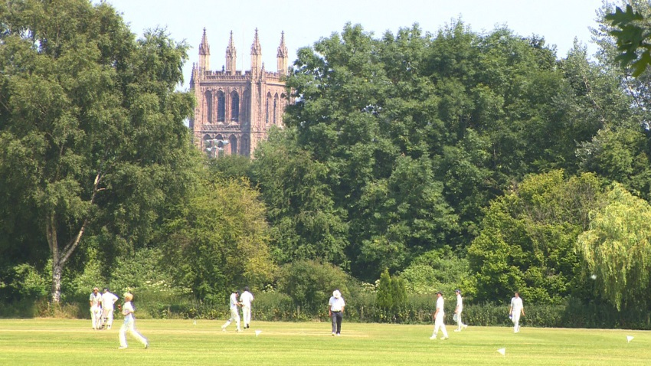
We are very much a family school, catering for pupils from age 3 to 18. Many of our pupils have siblings at the school, and in some cases their parents were here too. Pupils and parents are very loyal and supportive of ‘their’ school. We have a reputation for outstanding pastoral care and as a result pupils are remarkably tolerant and understanding of one another. It is important to us that every child is valued within our community. Good academic results are not enough: we seek to provide young people with the necessary skills and self-confidence to become well rounded, balanced adults who will make a positive contribution to those around them.

As a Cathedral School we expect pupils and staff to be sympathetic to our Christian ethos, although we welcome and value those of other faiths too.

“The children, from the nursery class eagerly talking about their book choices in the school library, to the reception children, busy with puzzles and problem solving, to Year 4s enthusiastically reciting poetry, are the best possible advertisement for the school. Each child we spent time with was friendly, relaxed, happy and engaged. Bouncing about full of things to talk about. You can pretty much hear their little brains fizzing. A delightful place to start exploring life’s possibilities.”
The Good Schools Guide Review 2013 of Hereford Cathedral Junior School

The Curriculum

Our curriculum is well planned, wide ranging and enriching. Its balance and focus on individual development, helps us to stimulate an enquiring mind, establishing key skills and a wealth of experience in our pupils that will be of great benefit to them for the future.

Whole School A Level Results: (of all grades)

 | % A* grade | % A*/A grades | % A*-B grades | % A*-C grades
2018 | 17 | 48 | 70 | 90
2017 | 25 | 49 | 70 | 90
2016 | 16 | 45 | 73 | 87
2015 | 23 | 55 | 80 | 93
2014 | 19 | 48 | 76 | 93

Whole School GCSE Results: (of all grades)

 | % A* grade | % A*/A grades | % A*-B grades | % A*-C grades
2018 | 34 | 53 | 72 | 94
2017 | 22 | 55 | 82 | 95
2016 | 28.2 | 56.7 | 81 | 95
2015 | 35.3 | 58.3 | 77.3 | 87.2
2014 | 32 | 59 | 82 | 94
“Pupils’ success is the result of teaching of high quality within a broad and interesting curriculum, which includes many trips and talks from visitors, as well as the provision of a wide range of extra-curricular activities.”

ISI Integrated Inspection 2014 of Hereford Cathedral Junior School
ISI Integrated Inspection 2014

Main Findings | ISI Grading: HCS | ISI Grading: HCJS
The quality of academic and other achievements and learning:
- The quality of the pupils’ achievements and learning | Excellent | Excellent
- The contribution of curricular and extra-curricular provision | Excellent | Excellent
- The contribution of teaching | Excellent | Excellent
The quality of the pupils’ personal development:
- The spiritual, moral, social and cultural development of the pupils | Excellent | Excellent
- The contribution of arrangements for pastoral care | Excellent | Excellent
- The contribution of arrangements for welfare, health and safety | Excellent | Excellent
The effectiveness of governance, leadership and management:
- The quality of governance | Excellent | Excellent
- The quality of leadership and management, including links with parents, carers. | Excellent | Excellent
“Staff know the pupils well and create a happy, friendly atmosphere, in which the pupils feel safe, secure and supported. They provide a high standard of help, guidance and monitoring, valued by the pupils and parents.

ISI Integrated Inspection 2014 of Hereford Cathedral School

A beautiful city, culture and a taste of tranquil countryside
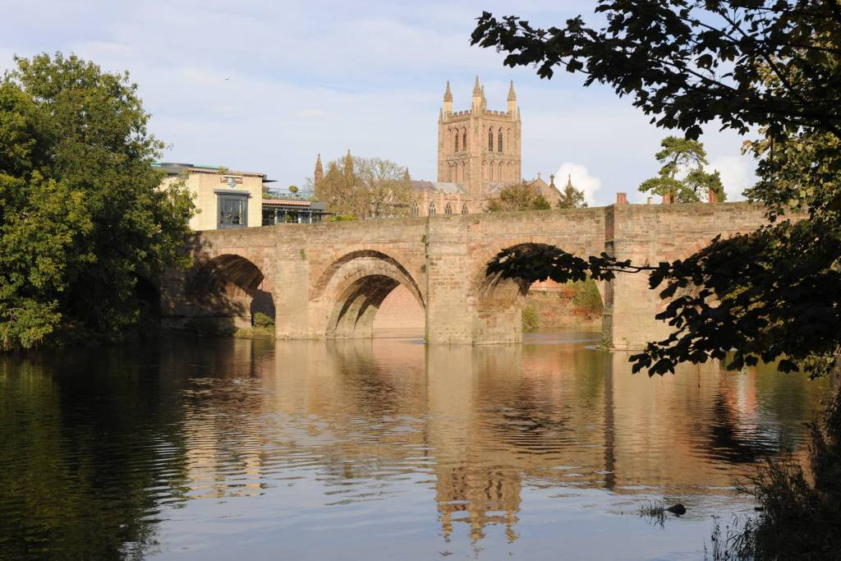
As a school we are fortunate to enjoy a position at the very heart of a fine cathedral city, at the centre of one of England’s least spoiled counties.

Hereford and the county beyond - with a range of housing to suit all tastes and price brackets, and ready access to beautiful countryside - affords an enviable quality of life. The River Wye flows past our doorstep through the city down to the Forest of Dean, while the Brecon Beacons, the Malvern Hills, Hay-on-Wye, with its internationally-acclaimed literary festival, and Ludlow, famous for its food festival, are all within easy commuting distance.

Hereford itself also offers a wide-range of independent eateries, great places to eat and drink; a new Odeon and a great shopping centre. Commuting is easy with great transport links to London, Birmingham and Cardiff.
A city renowned for its wonderful music, Hereford was also home to the composer Elgar for a significant period in his life. The cathedral and school play host to the Three Choirs Festival every three years, and everyday choral music of the very highest standard can be enjoyed at Evensong. For those with a more eclectic taste, the county is home to a host of talented musicians who regularly perform at venues and festivals across the region. It is little wonder that many people who have visited Hereford on holiday choose to settle in the area permanently.
www.visitherefordshire.co.uk

House Prices in Hereford (taken from www.rightmove.co.uk, 09.10.18)

Last year most property sales in Hereford involved semi-detached properties which sold for on average £205,540. Terraced properties sold for an average price of £171,048, while detached properties fetched £305,269.
Hereford, with an overall average price of £212,478, was similar in terms of sold prices to nearby Credenhill (£220,915), but was cheaper than Lugwardine (£362,500) and Fownhope (£312,139).

During the last year, sold prices in Hereford were 7% up on the previous year and 11% up on 2015 when the average house price was £191,575.

“Pupils are an absolute delight – very supportive of one another, articulate and appreciative. Comfortable in their own skin, but not full of themselves. Extremely positive about the School and proud of their achievements, but no trace of entitlement or arrogance – if they are a little on the quiet side one gets the impression that this is the result of not having to shout in order to be heard.”

The Good Schools Guide Review 2013 of Hereford Cathedral School

Quick Facts:

Hereford Cathedral Junior School (Head of Junior School: Mr Chris Wright)
28 Castle Street, Hereford HR1 2NW
Tel: 01432 363511, Email: enquiry@herefordcs.com, Website: www.herefordcs.com

Type: Day/Co-Education
Age Range: 3 to 11 years
Roll: 201 pupils
Fees: £2,676 to £3,440 per term
Inspection: ISI – Excellent in all areas (2014)
Affiliation: IAPS

Hereford Cathedral School (Headmaster: Mr Paul Smith)
Old Deanery, The Cathedral Close, Hereford HR1 2NG
Tel: 01432 363522, Email: schoolsec@herefordcs.com, Website: www.herefordcs.com

Type: Day/Co-Education
Age Range: 11 to 18 years
Roll: 504 pupils
Fees: £4,627 per term
Inspection: ISI – Excellent in all areas (2014)
Affiliation: HMC, CSA

“Parents are overwhelmingly positive and supportive of the School, and are very happy with the education their children receive.”

ISI Integrated Inspection 2014 of Hereford Cathedral School

Accountant

Location: Hereford Description: 37.5 hours per week, all year round
Salary: £31,280 -£33,895 per year (Support scale point 36-41)

Hereford Cathedral School is one of the oldest schools in the country, located in the beautiful surroundings of Cathedral Close. A happy, inclusive school with a national reputation for music, sport, and academic achievement, we offer pupils a personalised education helping individuals to set their sights high and feel valued for who they are.

We are seeking an Accountant to provide high level of professional accounting support.

Reporting to the Bursar, the post holders will be responsible for budgeting and forecasting, completing statutory and management accounts, effectively monitoring the accounts, communication with and providing financial training to non-finance managers and contributing to the continued development of the management reporting systems. They will also compile and present financial reports for the Governors of the School.

The post holder will manage the finance department and team.

Applicants must be a qualified accountant and member of a finance professional body (e.g. ACCA, CIMA) with evidence of continued professional development and an understanding of financial management process and systems.

We are looking for someone with experience of audit and/or managing and monitoring significant budgets. An understanding of working within the charitable sector would be an advantage.

Ability to effectively communicate financial matters to non-financial senior academics, prioritising tasks independently and remaining focused and capable of producing results is crucial to your success in the post.

It is vital that you possess demonstrable track record of proactively suggesting improvements and new methods of working and reporting, problem-solving and decision-making, coupled with a flexible outlook, willingness to adopt change and take ownership for work

Application forms can be downloaded from our website www.herefordcs.com and sent with a covering letter to Mrs Cath Knowles , HR Office, Hereford Cathedral School, Old Deanery, The Cathedral Close, Hereford HR1 2NG or email to c.knowles@herefordcs.com

The closing date for applications is Midday Wednesday 31st October 2018.

The School is committed to safeguarding and promoting the welfare of children and young people and expects all members of staff and volunteers to share this commitment. Appointments are subject to DBS clearance, satisfactory employment references and pre-employment checks.

Registered in Cardiff No 2081261 (Limited by Guarantee)
Registered Charity No 518889

We reserve the right to withdraw this advertisement at any time.

Job Description: Accountant

Post Title | Accountant  Based at The Old Deanery, Cathedral Close, Hereford HR1 2NG
Salary Point(s) | 36-41 £31,280 -£33,895
Hours/Weeks | Full time for 37.5 hours per week, all year round  This is a key supervisory and management post and the post holder will be expected to work such additional hours as may be necessary for the proper performance of duties.

Purpose of this Job Description:
Hereford Cathedral School considers this document as a “snapshot” of the job and the tasks listed are not an exhaustive list. It aims to provide a clear guide at the time of writing to all that is involved about the requirements of the job. It will also be used to communicate expectations about performance and will be used to monitor effective performance.

The Organisation
Hereford Cathedral School is one of the UK’s leading independent co-educational day schools. Providing boys and girls aged 3 to 18 with an excellent standard of teaching and individual care, offering them a broad range of opportunities to develop every aspect of their potential. The Hereford Cathedral School culture produces well-balanced, confident and considerate young adults ready for the wider world. We also benefit from one of the finest settings, adjacent to the beautiful Cathedral. We enjoy an air of tranquillity within a stone’s throw of the thriving city centre.

The School is committed to safeguarding and promoting the welfare of children and young people and expects all staff and volunteers to share this commitment.

Further information from http://www.herefordcs.com

Reporting Lines:
The post holder reports to the Bursar

Accountabilities:
- Prepare statutory and management accounts.
- Provide financial advice and support to colleagues to enable them to make sound business decisions
- Lead and Manage the Accounts department

Responsibilities:
- Preparation of year end accounts, along with dealing with the audit of the school and termly management accounts
- Prepare reports and present as required at the Governor Finance Committee
- Day to day accounts functions such as budget reviews, wage queries, fee queries
- Assessing bursary awards and renewals
- Preparation of fees in advance agreements
- Setting up Direct Debit/ParentPay/Salary Sacrifice/Childcare vouchers
- Dealing with utilities and lease contracts
- Investment and cash management
- Authorising payments
- Maintain fixed asset registers
- Gift aid claims and VAT
- Claiming Early Years Funding

Safeguarding and Protection of Children and Young Persons
In accordance with the Children’s Act 1989, on appointment post holders will be required to commit to their responsibilities with regards to safeguarding. In addition offers of appointment will be subject to an Enhanced criminal record check from the Disclosure and Barring Service (DBS).

These checks will highlight cautions, reprimands and final warnings as well as any convictions. The post holder must not have any spent or unspent convictions that would prevent working with children.

Health and Safety:
As an employee you are expected to:
- to take reasonable care of your own health and safety
- to take reasonable care not to put other people - fellow employees and members of the public - at risk by what you do or don't do in the course of your work
- to co-operate with your employer, making sure you get proper training and you understand and follow the company's health and safety policies
- not to interfere with or misuse anything that's been provided for your health, safety or welfare
- to report any injuries, strains or illnesses you suffer as a result of doing your job
- to tell your employer if something happens that might affect your ability to work (e.g. becoming pregnant or suffering an injury)

Particular H&S issues for this post are: DSE User

 |  | Person Specification
 |  | Essential Criteria | Desirable Criteria
Qualification |  | Qualified Professional Accounting Qualification (ACCA, CIMA, ACA or equivalent) | Educated to degree level or equivalent
Experience and Knowledge |  | Experience of auditing and/or producing budgets, statutory and management accounts for a comparable sized organisation (not likely to be less than 2 years)  Advanced Excel user  Experience of running computerised finance systems plus developing them to meet business needs  Experience of developing fit for purpose finance processes, procedures and controls and rolling them out the end users  Experience of cash flow management and forecasting | Knowledge of Charity Finance  Experience within an education setting  Line management experience  SAGE financial system
Skills |  | High level ability to analyse and interpret data and well developed analytical writing skills  Excellent interpersonal and communications skills particularly with non-finance staff  High numeracy and sound technical skills  Good time management skills and the ability to prioritise
Aptitude |  | Natural financial acumen and commercially aware  Confident to act on own initiative and be self-motivated  Naturally customer focussed, always considering the needs of the customer first  Natural attention to detail and an investigative nature  Readily keeps abreast of changes in financial regulations and legislation | Confident in dealings with Senior Leadership Team and Governors
Circumstances |  | Available to work flexibly to manage peaks in workload and in support of wider school functions from time to time
Safeguarding Children, Young People and Vulnerable Adults | Understands their role in the context of safeguarding children, young people and vulnerable adults  Ability to form and maintain appropriate relationships and personal boundaries with children and young people
Equal Opportunities | Understanding of the requirements of Equality and Diversity

