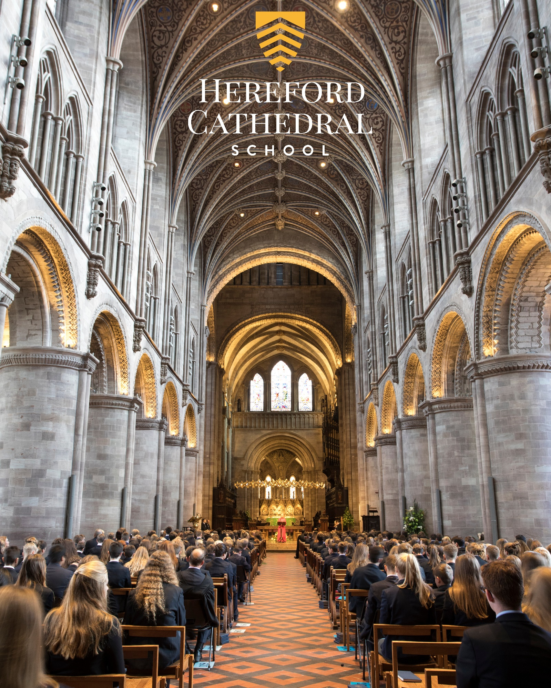
Teacher of Music
Candidate Information Booklet
HEREFORDCS.COM
01432 363522

Welcome
Thank you for your interest in working with us at Hereford Cathedral School. I hope that this information booklet will help provide you with some insight into our Cathedral School, Hereford city, and the outstanding county in which we are privileged to be located.

From our three year-olds in Nursery to our 18 year-olds in the Sixth Form, we seek to meet the specific needs of every pupil – providing stretch and challenge in the classroom and a wide variety of opportunities to develop individual interests, skills and self-esteem.

Alongside our small class sizes, excellent results and the outstanding range of opportunities on offer, we feel that our greatest strength lies in our friendly, family, inclusive ethos, encouraged by excellent staff pupil relations and a highly supportive parent body. It is this ethos, widely recognised as a special characteristic of the school, which enables pupils, young and old, to excel both in and out of the classroom.

The school is one of the UK’s leading independent co-educational day schools. We also benefit from the finest of settings, adjacent to a beautiful Cathedral and within a stone’s throw of the thriving city centre.

This is an exciting time in the development of the school and all of our teaching staff play their part in helping the school provide a lively, enriching and relevant curriculum.

I hope that the information provided in this pack gives you a sense of what to expect at Hereford Cathedral School and helps you to decide whether you might be interested in working with us. Please feel free to contact me directly if you have any further questions.

Paul Smith,
Headmaster

“Justifiably growing more self-assured, a school with a great deal to offer and an ethos of careful, thoughtful, nurture. Much to impress, with truly outstanding arts and music, a wide curriculum, a great sense of community service and genuine commitment to developing courage, confidence and a sense of adventure in even the quietest child.”

The Good Schools Guide Review 2013 of Hereford Cathedral School

Aims, Ethos & Vision

We provide boys and girls aged 3 to 18 with an excellent standard of teaching and individual care, offering them a broad range of opportunities to develop every aspect of their potential. The Hereford Cathedral School culture produces well-balanced, confident and considerate young adults ready for the wider world.

We seek:

- To meet pupils’ academic and personal needs and to promote the acquisition of moral values.
- To provide an environment in which pupils feel valued and learn to work co-operatively in a community.
- To provide a balanced, appropriate and challenging curriculum and a wide range of extra-curricular opportunities.
- To encourage pupils to achieve their academic potential and to foster a climate in which teaching and learning of high quality are given central priority.
- To ensure a high degree, within and outside the formal pastoral structure, of personal care, support and guidance.
- To respond to pupils’ aspirations and to be attentive to those of parents, and to their views.

As part of an ancient Cathedral foundation, and as a Choir School, which has the privilege of a Cathedral as its chapel, we are a Christian School in the Anglican tradition, although we welcome and value those of other denominations and faiths. Each pupil is encouraged to consider seriously and openly the Christian tradition within which the School is founded.

We place great value on maintaining close, constructive communication with parents and seek to establish the education of each pupil as a joint endeavour. While the academic development of each pupil is a central objective of both the school and the parent body, we seek, through example and ethos, to prepare our pupils for life beyond school by developing certain qualities and values. These include: self-discipline, diligence, acceptance of responsibility and challenge, regard for proper authority, honesty, courtesy, fairness, trustworthiness, loyalty, and sensitivity to the needs and views of others, courage, and the capacity to look to the future.

Our aim is to fulfil our charitable status through service to the local community by support for Cathedral choristers, charitable fundraising, the loan of buildings and other services to the community. Through competitive fee levels and the award of choristerships, scholarships, and bursaries, the pupil body reflects a wide cross-section of the local population.

A Brief History

Hereford Cathedral School is amongst the oldest schools in the United Kingdom and is thought to have been founded as a song school attached to Hereford Cathedral in Anglo-Saxon times. The first written reference of the School dates back to Bishop Gilbert’s letter of 26th December 1384 appointing Richard of Cornwall as Headmaster.

The Junior School (formerly Hereford Cathedral Preparatory School) is also equally rich in history and was founded in 1898, moving to its current location in 1925.

Life at the School

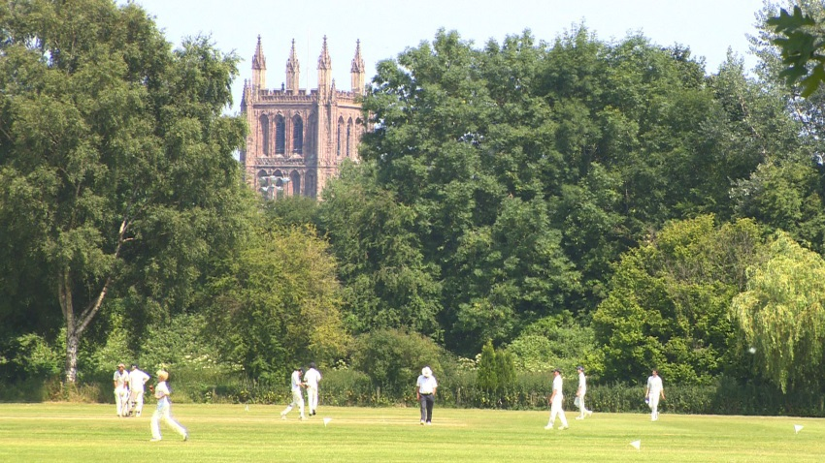
We are very much a family school, catering for pupils from age 3 to 18. Many of our pupils have siblings at the school, and in some cases their parents were here too. Pupils and parents are very loyal and supportive of ‘their’ school. We have a reputation for outstanding pastoral care and as a result pupils are remarkably tolerant and understanding of one another. It is important to us that every child is valued within our community. Good academic results are not enough: we seek to provide young people with the necessary skills and self-confidence to become well rounded, balanced adults who will make a positive contribution to those around them.

As a Cathedral School we expect pupils and staff to be sympathetic to our Christian ethos, although we welcome and value those of other faiths too.

“The children, from the nursery class eagerly talking about their book choices in the school library, to the reception children, busy with puzzles and problem solving, to Year 4s enthusiastically reciting poetry, are the best possible advertisement for the school. Each child we spent time with was friendly, relaxed, happy and engaged. Bouncing about full of things to talk about. You can pretty much hear their little brains fizzing. A delightful place to start exploring life’s possibilities.”

The Good Schools Guide Review 2013 of Hereford Cathedral Junior School

The Curriculum

Our curriculum is well planned, wide ranging and enriching. Its balance and focus on individual development, helps us to stimulate an enquiring mind, establishing key skills and a wealth of experience in our pupils that will be of great benefit to them for the future.

Whole School A Level Results: (of all grades)

 | % A* grade | % A*/A grades | % A*-B grades | % A*-C grades
2017 | 25 | 49 | 70 | 90
2016 | 16 | 45 | 73 | 87
2015 | 23 | 55 | 80 | 93
2014 | 19 | 48 | 76 | 93
2013 | 16 | 52 | 76 | 91

Whole School GCSE Results: (of all grades)

 | % A* grade | % A*/A grades | % A*-B grades | % A*-C grades
2017 | 22 | 55 | 82 | 95
2016 | 28.2 | 56.7 | 81 | 95
2015 | 35.3 | 58.3 | 77.3 | 87.2
2014 | 32 | 59 | 82 | 94
2013 | 35 | 63 | 84 | 97
“Pupils’ success is the result of teaching of high quality within a broad and interesting curriculum, which includes many trips and talks from visitors, as well as the provision of a wide range of extra-curricular activities.”

ISI Integrated Inspection 2014 of Hereford Cathedral Junior School
Music at Hereford Cathedral School
Originally founded to educate the choristers, Hereford Cathedral School remains true to its original founders and it would be true to say that music is not only a major flagship, but runs through the veins of the school. Every student is involved in music at one level or another, whether in singing in the ‘House Shout’, as part of the congregation, in musical productions or indeed more heavily involved as an instrumentalist or member of one of the many choirs. Music has an important role to play in the school’s culture, and is much more than merely a subject on a timetable. Its rich heritage has seen choral and organ scholarships at Oxbridge for the past successive 12 years. Many students take up places at conservatoires and the impressive list of alumni includes music lecturers, cathedral organists, freelance musicians, jazz musicians, teachers, and even most recently a King’s Singer!
A vibrant and happy environment, the Music School is housed in buildings along Castle Street which provides a base for 39 instrumental & vocal teachers, full-time teachers, a Music Administrator and part-time Music Librarian. Support is given from the extended musical community around the Close, and we enjoy a rich and fruitful relationship with the Dean and Chapter, many of whom are music graduates and understand what we do! The buildings host around 20 teaching/practice rooms all of which have reasonably new pianos. In addition there is an extensive music library in the basement, a percussion suite, a small music IT suite, and a new two manual pipe organ in the ‘Gilbert’ Room. Academic teaching is based in the three academic teaching areas, whilst larger rehearsals (bands, Symphony Orchestra, Chapel and Junior Choirs) use the much larger Zimmerman Room (school hall) adjacent to the Close.
The Music School offers a huge variety of co-curricular opportunities from the Renaissance music of the Gilbert Concert which plays period instruments, through to the Jazz Band. Many instrumentalists start in the Junior School and progress through. There are several string groups and two string orchestras for children. In the senior school there are many chamber groups on offer. Junior brass groups, and wind ensembles work in tandem with junior and senior bands with the intention of providing something meaningful and challenging for everyone at a multitude of levels. The more advanced students are invited to join the Symphony Orchestra which recently has performed works such as Saint Saens Symphony No.3 (Organ), Brandenburg Concerto No.5, Mozart Clarinet Concerto, Wagner Mastersingers Overture etc. Aural and theory lessons are a part of the music school programme and students are encouraged to attend. Cathedral School choirs are an integrated part of the culture, and we have sung at many of the country’s major cathedrals including St Paul’s, Westminster Abbey, St David’s, Wells, Gloucester, Worcester and Liverpool. All children in Year 7 sing in the Junior Choir; they can also sing in the Junior Chamber Choir (Colla Voce), then progress into Chapel Choir, the girls’ choir, Cantabile, and the Chamber Choir. We enjoy an excellent reputation for choral singing from the success of the Junior School choirs (Barnardo’s Choir of the Year) and Cantabile (BBC Songs of Praise Choir of the Year and Llangollen International Eisteddfod winner) through to the larger scale choral concerts in works such as Jenkins ‘The Armed Man’, Mozart Requiem, Haydn ‘Nelson’ Mass etc.
Outreach plays a pivotal role in the life of Music School. The Director of Music is presently a member of the Herefordshire Music education hub, and has responsibility for the large scale concerts within the county. As part of the school, the outreach music scheme runs two holiday courses (Easter and summer) and the Saturday Morning Music School which operates as a community music school for 30 weeks of the year throughout term time. This caters for around 100 local children and adults who want to learn an instrument or sing in either the adult choir/sight-singing class, or the Herefordshire Junior Youth Choir which we run.
Curriculum Music
All pupils in Years 7 and 8 have a double period of curriculum music each week. In addition, Year 7 has a double period of choral work (Junior Choir). Musical literacy features significantly in Years 8 & 9, and are seen very much as the foundation to each child having a good grounding either for further understanding and enjoyment of music, or indeed for further academic study. In Year 9 Music and Drama share the double period which operates in 6 weekly blocks throughout the year. Students opt for GCSE Music in Years 10 and 11, and likewise Music A-level in Years 12 and 13.
ISI Integrated Inspection 2014

Main Findings | ISI Grading: HCS | ISI Grading: HCJS
The quality of academic and other achievements and learning:
- The quality of the pupils’ achievements and learning | Excellent | Excellent
- The contribution of curricular and extra-curricular provision | Excellent | Excellent
- The contribution of teaching | Excellent | Excellent
The quality of the pupils’ personal development:
- The spiritual, moral, social and cultural development of the pupils | Excellent | Excellent
- The contribution of arrangements for pastoral care | Excellent | Excellent
- The contribution of arrangements for welfare, health and safety | Excellent | Excellent
The effectiveness of governance, leadership and management:
- The quality of governance | Excellent | Excellent
- The quality of leadership and management, including links with parents, carers. | Excellent | Excellent
“Staff know the pupils well and create a happy, friendly atmosphere, in which the pupils feel safe, secure and supported. They provide a high standard of help, guidance and monitoring, valued by the pupils and parents.

ISI Integrated Inspection 2014 of Hereford Cathedral School

A beautiful city, culture and a taste of tranquil countryside
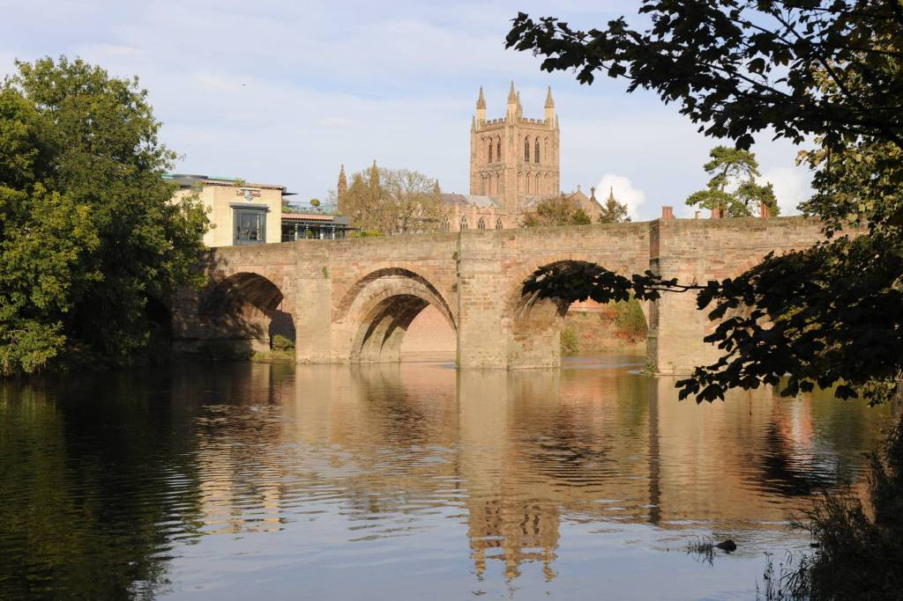
As a school we are fortunate to enjoy a position at the very heart of a fine cathedral city, at the centre of one of England’s least spoiled counties.

Hereford and the county beyond - with a range of housing to suit all tastes and price brackets, and ready access to beautiful countryside - affords an enviable quality of life. The River Wye flows past our doorstep through the city down to the Forest of Dean, while the Brecon Beacons, the Malvern Hills, Hay-on-Wye, with its internationally-acclaimed literary festival, and Ludlow, famous for its food festival, are all within easy commuting distance.

Hereford itself also offers a wide-range of independent eateries, great places to eat and drink; a new Odeon and a great shopping centre. Commuting is easy with great transport links to London, Birmingham and Cardiff.
A city renowned for its wonderful music, Hereford was also home to the composer Elgar for a significant period in his life. The cathedral and school play host to the Three Choirs Festival every three years, and everyday choral music of the very highest standard can be enjoyed at Evensong. For those with a more eclectic taste, the county is home to a host of talented musicians who regularly perform at venues and festivals across the region. It is little wonder that many people who have visited Hereford on holiday choose to settle in the area permanently.
www.visitherefordshire.co.uk

House Prices in Hereford (taken from www.rightmove.co.uk, 12.02.18)

Last year most property sales in Hereford involved semi-detached properties which sold for on average £200,261. Terraced properties sold for an average price of £161,439, while detached properties fetched £291,416.

Hereford, with an overall average price of £201,977 was cheaper than nearby Lugwardine (£265,714), Credenhill (£225,784) and Fownhope (£249,883).

During the last year, sold prices in Hereford were 4% up on the previous year and 5% up on 2015 when the average house price was £191,767.

“Pupils are an absolute delight – very supportive of one another, articulate and appreciative. Comfortable in their own skin, but not full of themselves. Extremely positive about the School and proud of their achievements, but no trace of entitlement or arrogance – if they are a little on the quiet side one gets the impression that this is the result of not having to shout in order to be heard.”

The Good Schools Guide Review 2013 of Hereford Cathedral School

Quick Facts:

Hereford Cathedral Junior School (Head of Junior School: Mr Chris Wright)
28 Castle Street, Hereford HR1 2NW
Tel: 01432 363511, Email: enquiry@herefordcs.com, Website: www.herefordcs.com

Type: Day/Co-Education
Age Range: 3 to 11 years
Roll: 226 pupils
Fees: £2,624 to £3,373 per term
Inspection: ISI – Excellent in all areas (2014)
Affiliation: IAPS

Hereford Cathedral School (Headmaster: Mr Paul Smith)
Old Deanery, The Cathedral Close, Hereford HR1 2NG
Tel: 01432 363522, Email: schoolsec@herefordcs.com, Website: www.herefordcs.com

Type: Day/Co-Education
Age Range: 11 to 18 years
Roll: 486 pupils
Fees: £4,536 per term
Inspection: ISI – Excellent in all areas (2014)
Affiliation: HMC, CSA

“Parents are overwhelmingly positive and supportive of the School, and are very happy with the education their children receive.”

ISI Integrated Inspection 2014 of Hereford Cathedral School

The Role: Teacher of Music

September 2018

Location: Hereford Description: Full time and permanent

Hereford Cathedral School seeks to appoint a talented, dynamic and enthusiastic Teacher of Music to join our hugely successful Music Department.

This is an exciting opportunity to gain wide experience in one of the leading music schools in the West Midlands. The post would suit an NQT or an ambitious teacher looking for career development

The post will encompass five areas:
- Academic Teaching Years 7 – 13
- Instrumental Teaching
- Chamber music/orchestral/band coaching
- Management
- Outreach

The role is extremely varied, but could be customised to play to the strengths of the right candidate. It is an exciting and varied post within this supportive, happy and thriving musical community, which takes an active role in both Herefordshire and Worcestershire.

The School was inspected by ISI in 2014 and graded “excellent” in each of the eight categories.

Hereford Cathedral School has a well-established and thriving extra-curricular programme, and the successful applicant will be expected to play an active part in this.

An application form and information pack may be downloaded from the school website www.herefordcs.com/job-vacancies. Completed applications should be accompanied by a covering letter and sent to Cath Knowles, HR Department, Hereford Cathedral School, Old Deanery, The Cathedral Close, Hereford HR1 2NG or to c.knowles@herefordcs.com

The closing date for applications is Midday on Wednesday 7th March 2018 with interviews scheduled for Week beginning 12th March 2018.

The School is committed to safeguarding and promoting the welfare of children and young people and expects all members of staff and volunteers to share this commitment. Appointments are subject to enhanced DBS clearance and satisfactory employment references and other safer recruitment checks.

Registered in Cardiff No 2081261 (Limited by Guarantee)
Registered Charity No 518889

Job Description: Teacher of Music

Post Title | Teacher of Music  Based at Old Deanery, The Cathedral Close, Hereford HR1 2NG
Work pattern | Full time
Salary | Competitive

Purpose of this Job Description:
Hereford Cathedral School considers this document as a “snapshot” of the job and the tasks listed are not an exhaustive list. It aims to provide a clear guide at the time of writing to all that is involved about the requirements of the job. It will also be used to communicate expectations about performance and will be used to monitor effective performance.

The job description which follows may, occasionally, be reasonably amended by the Headmaster:

The Organisation
Hereford Cathedral School is one of the UK’s leading independent co-educational day schools. Providing boys and girls aged 3 to 18 with an excellent standard of teaching and individual care, offering them a broad range of opportunities to develop every aspect of their potential. The Hereford Cathedral School culture produces well-balanced, confident and considerate young adults ready for the wider world. We also benefit from one of the finest settings, adjacent to the beautiful Cathedral. We enjoy an air of tranquillity within a stone’s throw of the thriving city centre.

The School is committed to safeguarding and promoting the welfare of children and young people and expects all staff and volunteers to share this commitment.
Further information from http://www.herefordcs.com

Reporting Lines:
The post holder reports to the Director of Music and Head of Academic Music

Accountabilities:
- To contribute to the Music Department by carrying out the professional duties of a teacher.
- Instrumental tuition to children from Year 3 to 13.
- To coach and direct chamber ensembles, to support large scale performances and to assist with the running of bands, orchestras, and choirs as appropriate.
- To manage one or two ensembles, liaising with conductors, outside agencies, organisations and agents.
- To take an active role in the Music Outreach Schemes.
- To maintain the department’s strong academic record.

Responsibilities:
- To teach Music and deliver an inspiring, challenging and balanced curriculum to students that supports the subject areas, in line with National Teaching Standards.
- To manage one of the school’s leading high profile choirs which regularly tours and competes in national and international competitions.
- To assess, record and report on the development, progress and attainment of pupils.
- To liaise with the Head of Department to ensure a coherent programme of study for pupils.
- To maintain good standards of behaviour amongst students, both when they are on School premises and when they are engaged in authorised School activities elsewhere.
- To assist in the planning and management of annual programmes, to take rehearsals in local state schools, assist with publicity and help on a regular basis with the Saturday morning Music School. To assist with the running and administration of two short holiday music courses (Easter and summer). To assist with concert management and liaison with professional orchestras, choirs, bands and agents.
- To participate in the development of the department and contribute to the departmental and overall School aims and objectives.
- To take part in the School’s professional development programme and take responsibility for your own professional development. Actively seeks to reflect on and enhance your own practice.
- To maintain appropriate records and provide relevant and accurate information for information systems to ensure that all records are up-to-date.
- To provide pastoral support to pupils as a form tutor or similar role as required.
- Undertake whole school duties as outlined annually including parents’ evenings.
- To support through involvement, the School’s co- and extra-curricular activities.
- Safeguard and promote the general well-being of pupils and to be a role model for pupils at all times.

Safeguarding and Protection of Children and Young Persons
In accordance with the Children’s Act 1989, on appointment post holders will be required to commit to their responsibilities with regards to safeguarding. In addition, offers of appointment will be subject to an Enhanced criminal record check from the Disclosure and Barring Service (DBS).

These checks will highlight cautions, reprimands and final warnings as well as any convictions. The post holder must not have any spent or unspent convictions that would prevent them from working with children.
Staff must inform the school if they are subject to criminal investigations or convicted while in the employment of the School.

Health and Safety:
As an employee you are expected to:
- take reasonable care of your own health and safety
- take reasonable care not to put other people - fellow employees and members of the public - at risk by what you do or don't do in the course of your work
- co-operate with your employer, making sure you get proper training and you understand and follow the company's health and safety policies
- not to interfere with or misuse anything that's been provided for your health, safety or welfare
- report any injuries, strains or illnesses you suffer as a result of doing your job
- tell your employer if something happens that might affect your ability to work (e.g. becoming pregnant or suffering an injury)
- if you drive or operate machinery, to tell your employer if you take medication that makes you drowsy

 | Person Specification
 | Essential Criteria | Desirable Criteria
Qualifications | Strong academic record: evidence of success at A-level and degree level.  Degree level qualification.  Qualifications in an appropriate instrument.  Evidence of involvement in relevant CPD. | Master’s degree or above.  Qualified Teacher Status.  Keyboard skills sufficient to accompany students.  Other relevant professional qualifications.
Experience and Knowledge | Excellent knowledge and understanding of the curriculum and a passion for the subject.  Knowledge and experience of lesson planning, use of resources and assessment.  Understanding of the theory and practice of effective teaching.  Knowledge of Safeguarding and Child Protection of Young People. | Experience of creating a positive learning environment for pupils.  Experience of performance, arranging and composition.  Experience of planning and managing music programmes.  Development of schemes of work.  Successful teaching at secondary/sixth form level (can be teaching practice)  Worked effectively as a form tutor.
Skills/Abilities | Build and maintain relationships through effective interpersonal skills.  Strong organisational and administrative skills.  Excellent communication skills to  inspire, challenge, motivate and empower others.  Think creatively to anticipate and solve problems.  Inclusive approach to education.  Ability to manage own time effectively.  Good IT knowledge in Microsoft Office applications to include Word, PowerPoint, Excel. | Motivate and inspire confidence in pupils, staff, parents, governors and the wider community in order to further develop and promote the school.  Ability to deliver feedback effectively.
Aptitude | Naturally demonstrates a ‘can do’ helpful attitude.  Work under pressure, maintaining a sense of perspective and humour.  Reliability and integrity.  Resilience and tenacity.  Commitment, honesty and dedication.  Shares the School’s values and vision and committed to the School’s vision for learning experience and outcomes for pupils.
Circumstances | Able to work flexibly, some earlier starts, evenings and weekends will be required.  A strong commitment to support the School’s extra-curricular activities programme.
Safeguarding Children, Young People and Vulnerable Adults | Understands their role in the context of safeguarding children, young people and vulnerable adults  Ability to form and maintain appropriate relationships and personal boundaries with children and young people.
Equal Opportunities | Understanding of the requirements of Equality and Diversity.

Declaration
I have received a copy of this job description and undertake to carry out the duties as described.

Employee Signature ………………………………………….Date……………………………..

Print name ……………………………………………………………………………………………………

