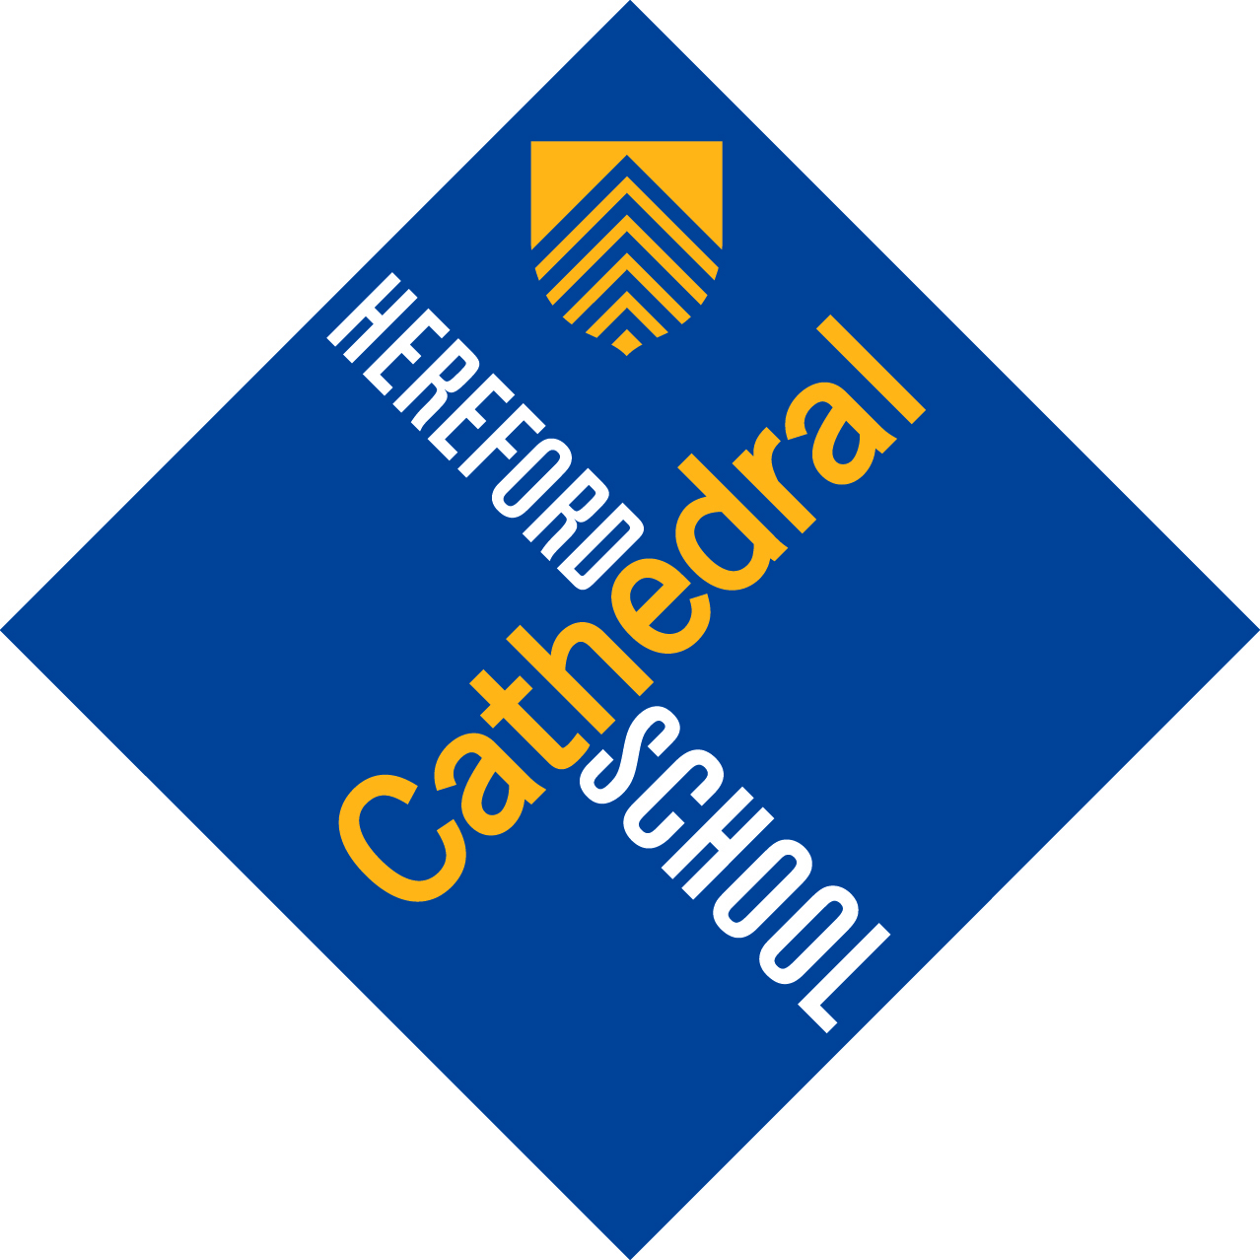

Hereford Cathedral Junior School
28 Castle Street
Hereford
HR1 2NW

Telephone 01432 363511

www.herefordcs.com

Curriculum Outline for Year 6 Autumn Term 2017

Please remember this is a summary and a guideline. Therefore it may be subject to alteration as circumstances change, at the teacher’s discretion.

English: This term, Year 6 will be studying ‘Millions’ by Frank Cottrell Boyce. Whilst reading this they will think about how the story is structured and narrated. They will consider the viewpoint of different characters and the motivation for their actions. This will lead onto pupils writing their own short stories and descriptions. Whilst reading the novel, pupils will develop their skills of inference and prediction whilst thinking carefully about the techniques the author uses to draw reactions from the reader. The pupils will also study some poetry and consider the different types of techniques used by the poet such as onomatopoeia. In November, Year 6 will also take part in a Shakespeare workshop on ‘Macbeth’ and study Shakespearean language. Pupils will revisit the different forms of punctuation and learn how to construct and punctuate complex sentences. Towards the end of term, pupils will look at biographies, thinking about their features, language and purpose. They will then research the lives of people that interest them and use that information to write their own biographies over the Christmas holidays.

Maths: During the first half of term, pupils will revise their existing knowledge of place value and then extend this understanding to include increasingly large numbers. Pupils will study types of numbers including prime, square, square roots, multiples and factors. They will extend their knowledge of rounding and estimation to give approximate answers to various levels of accuracy. Year 6 will also look at other number systems where pupils will be introduced to working in different number bases. In their calculation work, pupils will revise strategies for mental calculations involving addition, subtraction and multiplication. The first half of term will conclude with work on the properties of 2D shapes. During the second half of term, pupils will work with units of length and this will then be used to calculate perimeter. Work begun on multiplication in the first half of term will be extended to include long multiplication. Pupils will also revise mental and written methods of division using both the long and short written methods. Data handling work will centre on presenting data in tally chart and bar chart formats and pupils will then use collected data to calculate the mode, median, mean and range. Towards the end of the term, pupils will investigate the tessellational properties of regular and irregular shapes.

Science: In the first half of term, Year 6 will be studying Living things and their habitats. They will describe how living things including micro-organisms, plants and animals, are classified into broad groups according to common observable characteristics. Pupils will also give reasons for classifying plants and animals based on specific characteristics. In the second half of term, Year 6 will look at Evolution and inheritance. They will recognise that living things have changed over time and that fossils provide information about living things that inhabited the Earth millions of years ago. Pupils will also learn that living things produce offspring of the same kind, but normally offspring vary and are not identical to their parents. By the end of term, they will also be able to identify how animals and plants are adapted to suit their environment in different ways, and that adaptation may lead to evolution.

Humanities: In Year 6, pupils begin by looking at the Georgian era and developments in transport and industry at that time. There will be more grid reference work and we will then begin looking at the generation of electricity in advance of our project work next term on energy and the environment.

R.E: In R.E, pupils will start by thinking about Christian principles and how they play an important part in community life. This will lead into a discussion about rules, laws and the Ten Commandments. We will also look at the structure of the Bible and how Bible references can be used. Following this, we will look at the stories of the Good Samaritan and Zacchaeus and discuss the lessons that can be learned from them. This will lead into work on charities and the nature of giving. Pupils will finish the term by looking at the concept of being a ‘saint’.

French: We will begin by revising days, months and dates, then start on Unit 2 of the Heinemann book Expo 1. Pupils will be looking at the following topics this term: family and pets. Year 6 work involves more sentence work, use of bilingual dictionaries and a more detailed look at French phonics. Pupils will also look at some aspects of French culture.

Music: Year 6 will continue to work on their music-reading and vocal skills via the ocarina, class percussion orchestra and singing a selection of songs. They will be working on some songs in three-parts and also some sight-singing. There will be opportunities to perform and appraise instrumental music. Most of the lessons after half-term will be dedicated to preparing the music for the Celebration of Christmas and the Carol Service.

Art/D.T: This term in Year 6 pupils will be investigating the work of Bridget Riley and use this to design their own optical Art nameplate designs for their folders. The work of Roy Lichtenstein will also be investigated and a painting in the POP ART style will be composed. In Design and Technology this term Year 6 will investigate motion, design and construct a fairground ride. They will also complete a food technology Christmas project.

Drama: Drama: Year 6 will start the term being plunged into the fantasy characters from the ‘Spiderwick Chronicles’ where they will think about character, feelings and portraying emotions with elves, trolls, dwarves and goblins galore! Linking to their work in Humanities, pupils will make a steam engine out of their bodies and put this movement to music by the 70's electronic German band 'Kraftwerk'. Inspiration will then be taken from the Georgian fan-light design and iron bridge structure, and the children will think about shape and movement and pattern in their work. After half term, the children will learn about Greek Theatre and will devise a play suitable for Year 3 to watch. They will write their own scripts and think about dramatic ways to build tension.

I.C.T: Year 6 will use different forms of multimedia to research, design and produce a presentation on a chosen topic. They will continue to develop their Coding skills using Espresso Coding and Scratch to design, code and create a multilevel game. They will learn more about Cloud computing with Microsoft One Drive and Office 365 as well as looking at more advanced research methods, and the validity of information and websites on the internet. Later in the term, they will discuss and learn about sensible, safe and acceptable behaviour online and understand the importance of privacy/location settings on social media sites/apps and mobile devices. They will continue to practice touch typing skills using Typing Web as well as continuing to use software such as Microsoft Word, Excel and Publisher.

P.S.H.E: Year 6 will be thinking about how to take part in a debate. They will prepare for a debate and consider how to deal with opposing views. As part of this work, they will think about what makes a successful debate and the skills needed to effectively persuade an audience. This will lead onto how decisions are made in school and the role of the pupils, school council, house captains and heads of school. Year 6 will also think about difficult choices they have to make, the nature of the decision making process and the importance of making informed decisions. Towards the end of term, Year 6 will think about issues regarding animal rights and the environment.

Games and P.E: Year 6 will be playing basketball and honing the skills they have worked on previously. Apart from handling, passing, shooting and dribbling, children will be encouraged to look for space and move around the court. Team work will be vital, as will communication and the speed of play. In the second half of term, the children will be partaking in health related fitness, working at a variety of circuit style activities.
Year 6 Girls will be playing hockey and the boys, rugby. For the boys, this will mean playing a new form of rugby with different rules from those they were playing to last year.

