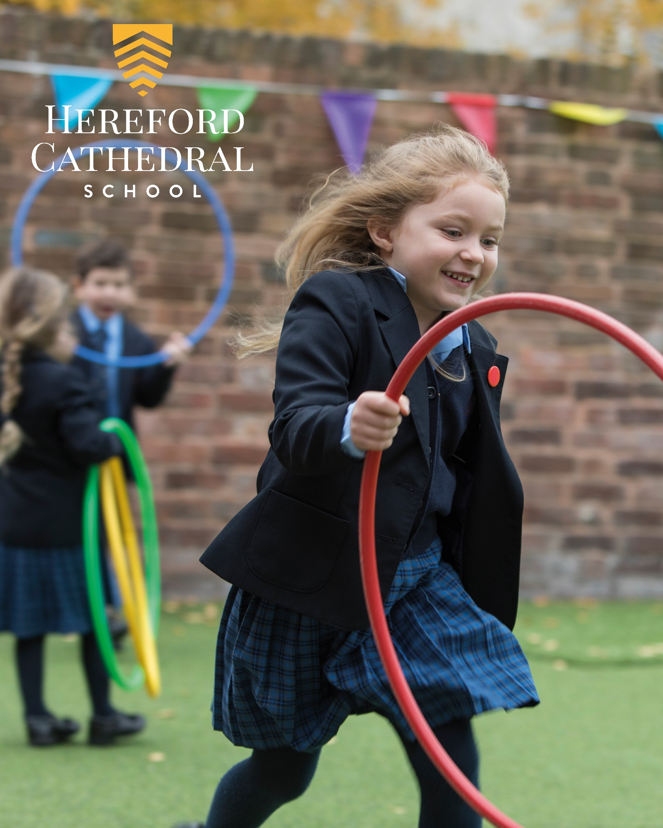
Junior School Nursery Deputy
Candidate Information Booklet
HEREFORDCS.COM
01432 363511

Welcome
Thank you for your interest in the position of Nursery Deputy at Hereford Cathedral Junior School.

This position provides an opportunity for you to play a pivotal role in the life of a thriving and happy school.

Hereford Cathedral Junior School educates 220 children aged from 3 to 11. Through strong pastoral care, small classes, a mixture of class based and subject specialist teaching and the wide range of activities on offer, we seek to meet the specific needs of every pupil – providing stretch and challenge in the classroom and a wide variety of opportunities to develop individual interests, skills and self-esteem.

We are proud of our children – their enthusiasm, relationships and behaviour. These characteristics underpin all that we achieve – and our staff and children achieve a great deal! All that we do – in the classroom, on the stage, on the games field and musically too - is characterised by our enthusiastic and well behaved children.

The Nursery Deputy will be based Junior School, at 28 Castle Street, and specifically within our Nursery on Quay Street. As Nursery Deputy, you will play a pivotal role in our school, working alongside the Nursery Leader and assisting in the delivery of high quality education and care for which our Nursery is well known.

Our Nursery is located in a self-contained, specially adapted building which is bright, welcoming and secure; children and staff also have access to all school facilities. Our Nursery accepts children from the age of three.

You will find further details of our school and the role in this booklet, as well as details about how to apply, the closing date and proposed interview date. In the meantime, please do feel you can get in touch if you have any queries or would like to discuss the role – either with our HR Officer, Cath Knowles (c.knowles@herefordcs.com), or directly with me.

I look forward to hearing from you!

Chris Wright
Head of the Junior School
c.wright@herefordcs.com

ISI Integrated Inspection of Hereford Cathedral School 2014

Main Findings | ISI Grading: HCS | ISI Grading: HCJS
The quality of academic and other achievements and learning:
- The quality of the pupils’ achievements and learning | Excellent | Excellent
- The contribution of curricular and extra-curricular provision | Excellent | Excellent
- The contribution of teaching | Excellent | Excellent
The quality of the pupils’ personal development:
- The spiritual, moral, social and cultural development of the pupils | Excellent | Excellent
- The contribution of arrangements for pastoral care | Excellent | Excellent
- The contribution of arrangements for welfare, health and safety | Excellent | Excellent
The effectiveness of governance, leadership and management:
- The quality of governance | Excellent | Excellent
- The quality of leadership and management, including links with parents, carers and | Excellent | Excellent

HCS: Hereford Cathedral School / HCJS: Hereford Cathedral Junior School
ISI use a four point grading scale when making judgements of quality, these are ‘Excellent’, ‘Good’, ‘Sound’ or ‘Unsatisfactory’.

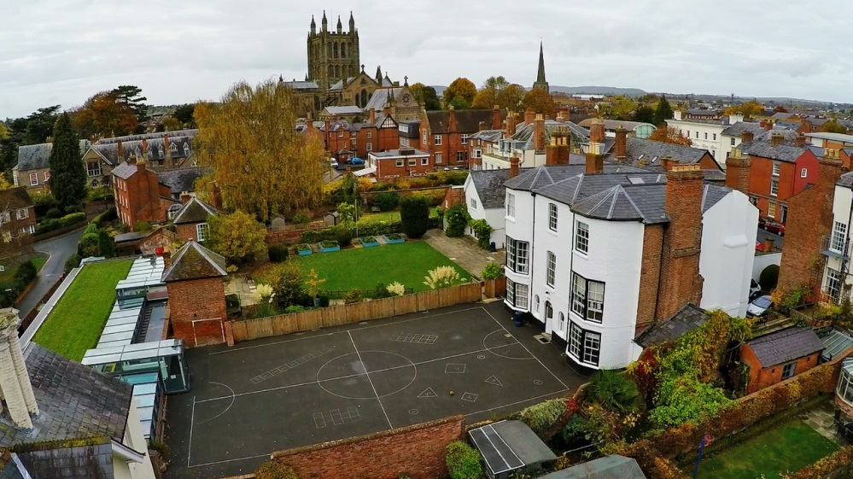

“The children, from the nursery class eagerly talking about their book choices in the school library, to the reception children, busy with puzzles and problem solving, to Year 4s enthusiastically reciting poetry, are the best possible advertisement for the school. Each child we spent time with was friendly, relaxed, happy and engaged. Bouncing about full of things to talk about. You can pretty much hear their little brains fizzing. A delightful place to start exploring life’s possibilities.”

The Good Schools Guide Review 2013 of Hereford Cathedral Junior School

Aims, Ethos & Vision

We provide boys and girls aged 3 to 18 with an excellent standard of teaching and individual care, offering them a broad range of opportunities to develop every aspect of their potential. The Hereford Cathedral School culture produces well-balanced, confident and considerate young adults ready for the wider world.

We seek:

- To meet pupils’ academic and personal needs and to promote the acquisition of moral values.
- To provide an environment in which pupils feel valued and learn to work co-operatively in a community.
- To provide a balanced, appropriate and challenging curriculum and a wide range of extra-curricular opportunities.
- To encourage pupils to achieve their academic potential and to foster a climate in which teaching and learning of high quality are given central priority.
- To ensure a high degree, within and outside the formal pastoral structure, of personal care, support and guidance.
- To respond to pupils’ aspirations and to be attentive to those of parents, and to their views.

As part of an ancient Cathedral foundation, and as a Choir School, which has the privilege of a Cathedral as its chapel, we are a Christian School in the Anglican tradition, although we welcome and value those of other denominations and faiths. Each pupil is encouraged to consider seriously and openly the Christian tradition within which the School is founded.

We place great value on maintaining close, constructive communication with parents and seek to establish the education of each pupil as a joint endeavour. While the academic development of each pupil is a central objective of both the school and the parent body, we seek, through example and ethos, to prepare our pupils for life beyond school by developing certain qualities and values. These include: self-discipline, diligence, acceptance of responsibility and challenge, regard for proper authority, honesty, courtesy, fairness, trustworthiness, loyalty, sensitivity to the needs and views of others, courage, and the capacity to look to the future.

Our aim is to fulfil our charitable status through service to the local community by support for Cathedral choristers, charitable fundraising, the loan of buildings and other services to the community. Through competitive fee levels and the award of choristerships, scholarships, and bursaries, the pupil body reflects a wide cross-section of the local population.

A Brief History

Hereford Cathedral Junior School started life as The Cathedral Preparatory School in 1898 in a tin shed in the grounds of 5 Harley Court where less than one dozen boys were taught by two spinster ladies. Over the years the School grew and was privately owned and run for most of its history. It moved to its current location, 28 Castle Street, in 1925 and has grown to occupy a number of buildings in the street. It became co-educational in 1990 and part of the wider Hereford Cathedral School in 1994. It has close links with the Cathedral as it continues to educate the choristers.

Life at the School

We are very much a family school, catering for pupils from age 3 to 18. Many of our pupils have siblings at the school, and in some cases their parents were here too. Pupils and parents are very loyal and supportive of ‘their’ school. We have a reputation for outstanding pastoral care and as a result pupils are remarkably tolerant and understanding of one another. It is important to us that every child is valued within our community. Good academic results are not enough: we seek to provide young people with the necessary skills and self-confidence to become well rounded, balanced adults who will make a positive contribution to those around them.

As a Cathedral School we expect pupils and staff to be sympathetic to our Christian ethos, although we welcome and value those of other faiths too

“The School successfully meets its aim to help pupils reach their academic potential by creating a supportive learning environment in which they (the pupils) develop a love of learning and feel able to take risks and develop ideas”

“Pupils’ success is the result of teaching of high quality within a broad and interesting curriculum, which includes many trips and talks from visitors, as well as the provision of a wide range of extra-curricular activities.”

“Pupils of all ages thrive, are confident, and are at ease with themselves and with their peers and the adults with whom they come into contact.”

(ISI Integrated Inspection 2014 of Hereford Cathedral Junior School)

Hereford and Herefordshire

A cosmopolitan city, culture and a taste of tranquil countryside
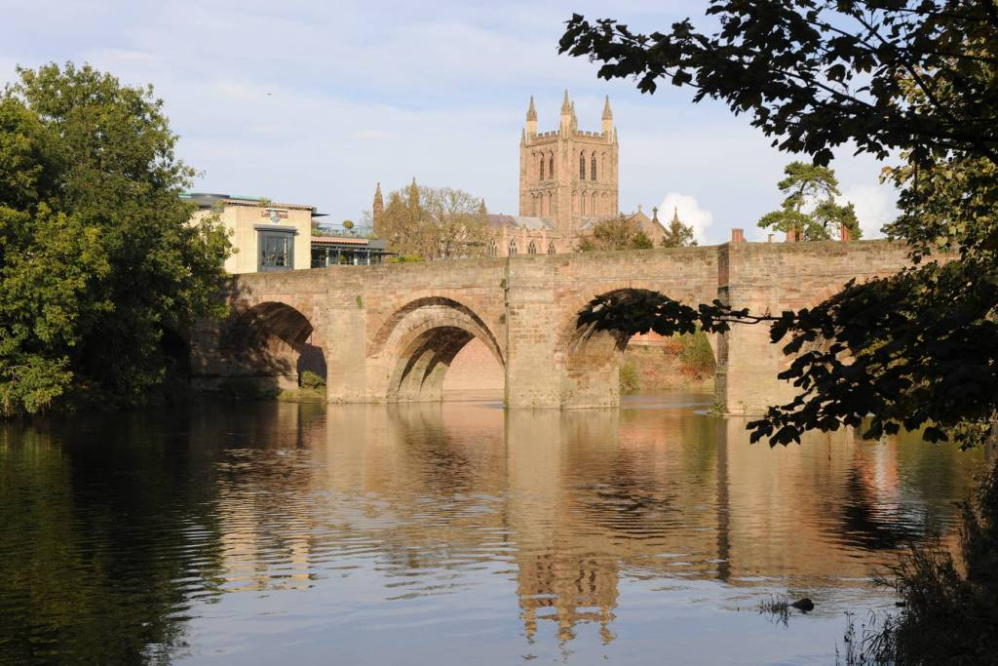
As a school we are fortunate to enjoy a position at the very heart of a fine cathedral city, at the centre of one of England’s least spoiled counties.

Hereford and the county beyond - with a range of housing to suit all tastes and price brackets, and ready access to beautiful countryside - affords an enviable quality of life. The River Wye flows past our doorstep through the city down to the Forest of Dean, while the Brecon Beacons, the Malvern Hills, Hay-on-Wye, with its internationally-acclaimed literary festival, and Ludlow, famous for its food festival, are all within easy commuting distance.

Hereford itself also offers a wide-range of independent eateries, great places to eat and drink; a new Odeon and a great shopping centre. Commuting is easy with great transport links to London, Birmingham and Cardiff.
A city renowned for its wonderful music, Hereford was also home to the composer Elgar for a significant period in his life. The cathedral and school play host to the Three Choirs Festival every three years, and everyday choral music of the very highest standard can be enjoyed at Evensong. For those with a more eclectic taste, the county is home to a host of talented musicians who regularly perform at venues and festivals across the region. It is little wonder that many people who have visited Hereford on holiday choose to settle in the area permanently. (www.visitherefordshire.co.uk)

Quick Facts

Hereford Cathedral Junior School (Head of Junior School: Mr Chris Wright)
28 Castle Street, Hereford HR1 2NW
Tel: 01432 363511, Email: enquiry@herefordcs.com, Website: www.herefordcs.com

Type: Day/Co-Education
Age Range: 3 to 11 years
Roll: 220 pupils
Fees: £2,085 to £3,373 per term
Inspection: ISI – Excellent in all areas (2014)
Affiliation: IAPS

Hereford Cathedral School (Headmaster: Mr Paul Smith)
Old Deanery, The Cathedral Close, Hereford HR1 2NG
Tel: 01432 363522, Email: schoolsec@herefordcs.com, Website: www.herefordcs.com

Type: Day/Co-Education
Age Range: 11 to 18 years
Roll: 495 pupils
Fees: £4,536 per term
Inspection: ISI – Excellent in all areas (2014)
Affiliation: HMC

“Parents are overwhelmingly positive and supportive of the School, and are very happy with the education their children receive.” (ISI Integrated Inspection 2014 of Hereford Cathedral Junior School)

“Pupils are an absolute delight – very supportive of one another, articulate and appreciative. Comfortable in their own skin, but not full of themselves. Extremely positive about the School and proud of their achievements, but no trace of entitlement or arrogance – if they are a little on the quiet side one gets the impression that this is the result of not having to shout in order to be heard.” (The Good Schools Guide Review 2013 of Hereford Cathedral School)

The Role: Nursery Deputy

Location: Hereford Cathedral Junior School, 28 Castle Street, Hereford, and specifically in our Nursery on Quay Street

Starting date: 3rd September 2018.

Work pattern: full time (term time only). Currently this post is term time only, though there may be need for an increase working hours in the future.

Salary: £16,909 -£18,455 – starting salary of £12,968 per year, for the work pattern detailed above.

Hereford Cathedral Junior School seeks a capable, experienced and personable Nursery Deputy, to support the Nursery Leader. As Nursery Deputy, you will play a pivotal role in our school, welcoming new children and families and overseeing the delivery of high quality education and care for which our Nursery is well known.

Our Nursery is located in a self-contained, specially adapted building which is bright, welcoming and secure; children and staff also have access to all school facilities. Our Nursery accepts children from the age of three.

The school has high standards across the board and an enviable reputation for Sport, Music and Drama. It was found to be “excellent” in each of the eight categories by ISI in its last inspection.

An application form and information pack, including details of opportunities to visit the school, may be downloaded from the school website www.herefordcs.com/job-vacancies. Completed applications should be accompanied by a covering letter and sent to Mrs Cath Knowles, Hereford Cathedral School, Old Deanery, The Cathedral Close, Hereford HR1 2NG or to c.knowles@herefordcs.com .

The School is committed to safeguarding and promoting the welfare of children and young people and expects all members of staff and volunteers to share this commitment. Appointments are subject to DBS clearance, satisfactory employment references and pre-employment checks.

The Application Process

Opportunity for potential candidates to visit the school: 13th June 0845-1000.
Please contact Mrs Lucy Stonehouse, Head’s PA (l.stonehouse@herefordcs.com) to register, or to organise an alternative time if necessary.
Candidates will not be disadvantaged if they do not visit the school before applying.

Closing Date: 9am on Thursday 21st June.
All applications will be acknowledged.

Interview date: Tuesday 26th June.
During the day, candidates will have ample opportunity to get a feel for the school, meeting children and staff.

The School is committed to safeguarding and promoting the welfare of children and young people and expects all members of staff and volunteers to share this commitment. Appointments are subject to DBS clearance, satisfactory employment references and pre-employment checks.

Registered in Cardiff No 2081261 (Limited by Guarantee)
Registered Charity No 518889
Job Description: Nursery Deputy

Post Title | Nursery Deputy  Based at Junior School, 28 Castle Street, Hereford HR1 2NW
Salary Point(s) | £16,909 -£18,455 (9-12)– starting salary of £12,968 per year
Hours/Weeks | Full time. Currently this post is term time only, though there may be need for an increase working hours in the future.

Purpose of this Job Description:
Hereford Cathedral School considers this document as a “snapshot” of the job and the tasks listed are not an exhaustive list. It aims to provide a clear guide at the time of writing to all that is involved about the requirements of the job. It will also be used to communicate expectations about performance and will be used to monitor effective performance.

The Organisation
Hereford Cathedral School is one of the UK’s leading independent co-educational day schools. Providing boys and girls aged 3 to 18 with an excellent standard of teaching and individual care, offering them a broad range of opportunities to develop every aspect of their potential. The Hereford Cathedral School culture produces well-balanced, confident and considerate young adults ready for the wider world. We also benefit from one of the finest settings, adjacent to the beautiful Cathedral. We enjoy an air of tranquillity within a stone’s throw of the thriving city centre.
The School is committed to safeguarding and promoting the welfare of children and young people and expects all staff and volunteers to share this commitment.
Further information from http://www.herefordcs.com

Reporting Lines: The post holder reports to the Head of Junior School, in liaison with the Head of EYFS.

Accountabilities:
- To act as Nursery Deputy

Responsibilities:
- Work under the guidance of the Nursery Leader and Head of EYFS
- Assist in the day to day running of Nursery
- Assist in planning and delivering a broad and imaginative EYFS curriculum, in liaison with the Nursery Leader and Head of EYFS
- To have an excellent knowledge of, and to keep up to date with educational changes in, the EYFS
- To assist with the keeping of records: including permission forms, medical lists, register, medicine and accident records, children’s records (stepping stones), EYFS progress records and observations
- To assist with completing risk assessments
- To assist in maintaining a creative, stimulating Nursery environment
- To support the Nursery Leader in conducting parent consultations
- To follow Nursery policies and procedures in line with whole school policies and the EYFS Statutory Framework, in liaison with the Head of EYFS
- First aider
- Assist with the induction of new children into Nursery
- To assist in preparing children for transfer into Reception

Safeguarding and Protection of Children and Young Persons
In accordance with the Children’s Act 1989, on appointment post holders will be required to commit to their responsibilities with regards to safeguarding. In addition offers of appointment will be subject to an Enhanced criminal record check from the Disclosure and Barring Service (DBS).

These checks will highlight cautions, reprimands and final warnings as well as any convictions. The post holder must not have any spent or unspent convictions that would prevent working with children.

Health and Safety:
As an employee you are expected to:
- to take reasonable care of your own health and safety
- to take reasonable care not to put other people - fellow employees and members of the public - at risk by what you do or don't do in the course of your work
- to co-operate with your employer, making sure you get proper training and you understand and follow the company's health and safety policies
- not to interfere with or misuse anything that's been provided for your health, safety or welfare
- to report any injuries, strains or illnesses you suffer as a result of doing your job
- to tell your employer if something happens that might affect your ability to work (e.g. becoming pregnant or suffering an injury)
- if you drive or operate machinery, to tell your employer if you take medication that makes you drowsy

Particular H&S issues for this post are:
- sit and use standard office VDU equipment plus other office equipment

 | Person Specification
 | Essential Criteria |  | Desirable Criteria
Qualification |  | Completed a broad education with GCSE grade C and above in English Language and Maths (or equivalent)  Hold a full and relevant level 3 qualification | Hold a full and relevant qualification above level 3  Hold a full paediatric first aid qualification
Experience and Knowledge |  | At least two years’ experience of working in an early years setting
Skills |  | Good time management  Use initiative  Work as part of a team  Excellent communication skills  Excellent interpersonal skills  Excellent practitioner who can form excellent relationships with children and families  Have an excellent knowledge of child development and the pedagogy of learning in the early years  To demonstrate a self- reflective practice and a good working knowledge of educational initiatives in EYFS
Aptitude |  | Can take responsibility and is not afraid to make decisions  Excellent attention to detail  Discretion at all times and confidentiality when appropriate  Be articulate, presentable, co-operative, reliable, customer responsive with a “can do” attitude  Enjoy working as part of a team. Have a good sense of humour and perspective  Creates good rapport with staff, parents and pupils
Circumstances |  | Willing and able to work flexibly, for example providing after school care, as required
Safeguarding Children, Young People and Vulnerable Adults | Understands their role in the context of safeguarding children, young people and vulnerable adults  Ability to form and maintain appropriate relationships and personal boundaries with children and young people
Equal Opportunities | Understanding of the requirements of Equality and Diversity

Declaration
I have received a copy of this job description and undertake to carry out the duties as described.

Employee Signature ……………………………………………….. Date ………………….

Print name ……………………………………………………………………………..…………..

