Dear Parents,

HCJS PTA SUMMER BALL – SATURDAY 9th JUNE 2018

The PTA are delighted to invite you to the 2018 HCJS PTA Summer Ball on Saturday 9th June at Left Bank (River Terrace) at 7pm for 7.30pm dinner. Carriages at 1.30am. The dress code is ‘Black Tie with a Hint of Great Gatsby’.
Tickets will be priced at £65.00 per person and there will be an Early Bird Offer price of £60.00 for all tickets paid for before 30th April. Tickets are sold on an individual basis but there is an opportunity to specify with whom you would like to sit (e.g Year 4 parents) and all efforts will be made to accommodate such requests. Similarly, we are happy to accommodate the purchase of a table of 10 guests if preferred but request that you specify this on your response with a list of all guest names and any dietary requirements for the relevant guests.

The ball will be a dinner and dance format with a drinks reception, three course sit down meal and live music and disco. There will be an auction prior to the music, where we hope to raise some funds for the school PTA (if you are able to donate any prizes for the auction over the next month, we would be extremely grateful)!

The meal is being provided by Taste Catering who are being brought to the venue to deliver the catering for the event. You can see their food at this link: Taste Catering. The live music is being provided by Frontrunner, their Facebook page (which has lots of You Tube videos on of their sets can be found here: Front Runner.

Please could you either complete the below form and return to the School Office or email juniorpta@herefordcs.com to RSVP with the details requested below. We will not be issuing paper invitations but will be running a guest list on the evening.
Payment must be made either via cheque or cash to the school office or in the PTA tray. We can also accept payment by BACS if you would prefer, please email for bank details.

The invitation is extended to all parents of HCJS and their guests.

If you have any questions or queries please do not hesitate to contact the PTA Committee or your class representative.

We look forward to welcoming you on the night!

Kind regards
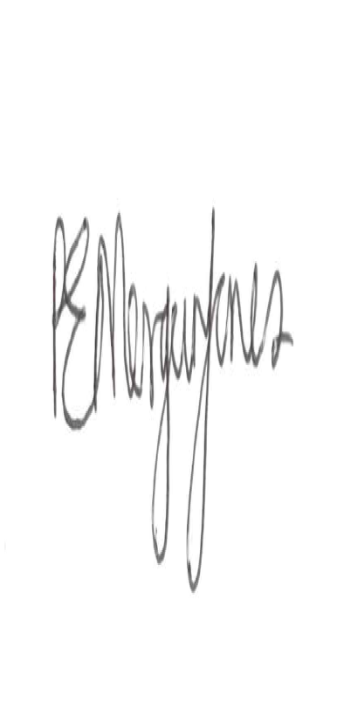

Rebecca Morgan-Jones
PTA Chair

HCJS PTA SUMMER BALL RESPONSE FORM

Guest Names (please continue overleaf if necessary) | Son/Daughter Year Group(s) where applicable | Any Dietary Requirements (please specify)
Number of tickets
Seating Request (e.g Year 4 parents)
Total (£)
Payment Method (please circle) | BACS | CHEQUE (made payable to HCJS PTA)
 | CASH

