GCSE CHEMISTRY REVISION GUIDES

Teachers and students make use of Oxford University Press textbooks during the course of the year. These provide great detail and also examples to help illustrate new concepts.
However we have found that near examination time, some pupils prefer to have a more concise version of the specification to help with revision, and reinforce mark schemes.
If you are thinking of buying a revision guide for the new 1-9 GCSE courses ( from 2016 onwards) , the ones we recommend are listed below.
They can be ordered on line from :
https://global.oup.com/education/content/secondary/series/aqa-gcse-science-3ed/?view=ProductList&region=uk
or,
www.cgpbooks.co.uk

but are also available from W.H. Smith , http://www.whsmith.co.uk/

- AQA CHEMISTRY TRIPLE AWARD - SEPARATE SCIENCES
Choose between these two alternatives.
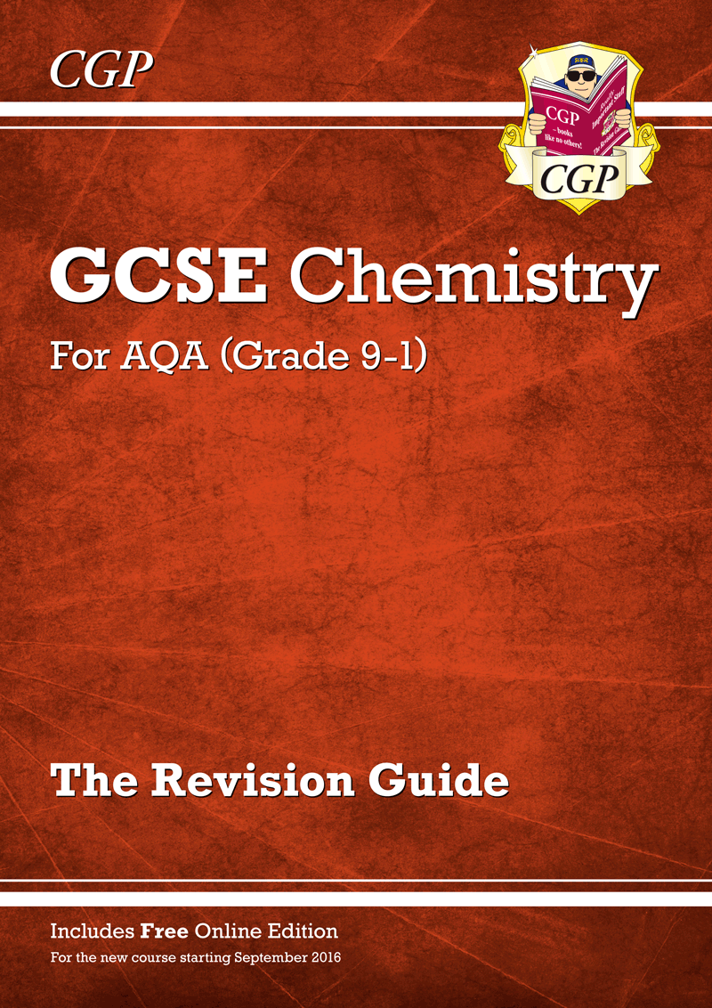
RRP : £5.95
Publisher: CGP
ISBN: 978 1 78294 577 2

OR
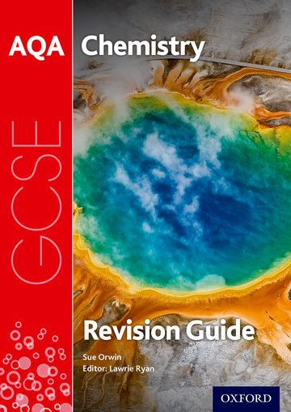

RRP: £7.25
Publisher: Oxford University Press
ISBN: 978 0 19 835941 8

2. AQA CHEMISTRY DUAL AWARD
Choose between these two alternatives.
AQA ‘Chemistry for Combined Science ’ ( Trilogy)

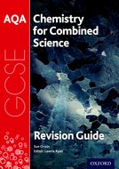

RRP: £5.50
Publisher: Oxford University Press
ISBN: 978 0 19 835931 9

OR
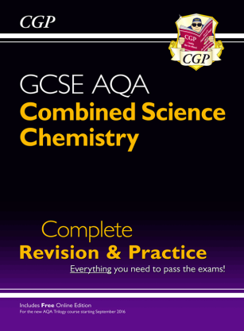

RRP: £7.50
Publisher: CGP
ISBN: 978 1 78 294587 1

