A LEVEL CHEMISTRY REVISION GUIDES
We started teaching a new ‘A’ level specification from OCR in September 2015.
Teachers and students make use of textbooks during the course of the year. These provide great detail and also examples to help illustrate new concepts.
However we have found that near examination time, some pupils prefer to have a more concise version of the specification to help with revision, and reinforce mark schemes.
If you are thinking of buying a revision guide for the A level course, the one we recommend is show below.
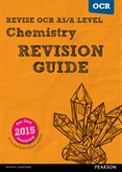
ISBN 978-1-4479-8437-5
It can be ordered online for £9.99 using the following link:
http://www.pearsonschoolsandfecolleges.co.uk/Secondary/Science/16Biology/OCR-A-level-Science-2015/ISBN/Revision-Guides-and-Workbooks/ReviseOCRAlevel2015ChemistryRevisionGuidePack.aspx
An alternative is available from CGP each costing £10.99 , but they have separate books for Lower and Upper Sixth
ISBN 978-1-78294-290-0 ISBN 978-1-78294-340-2
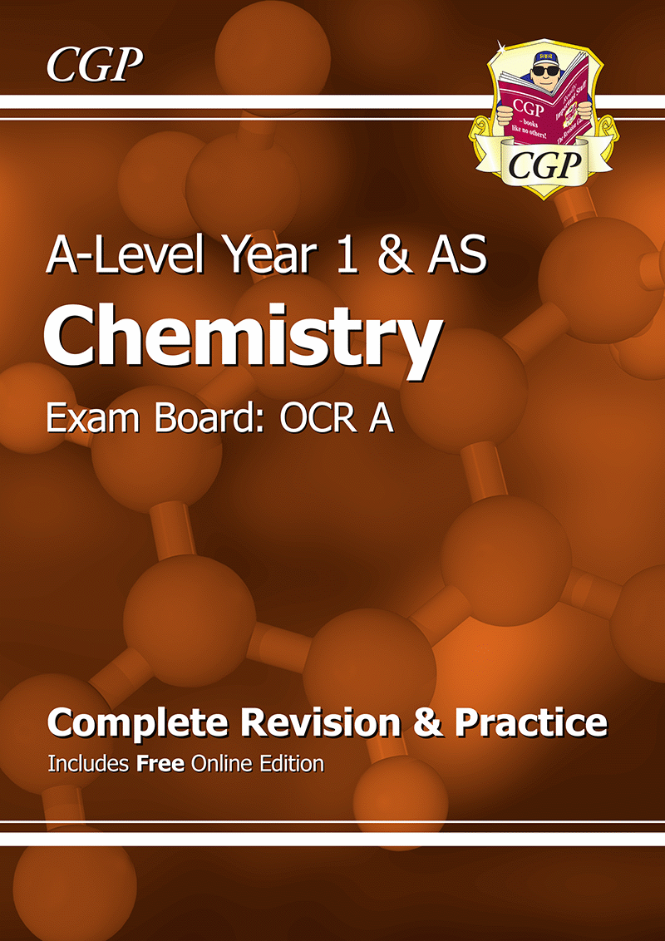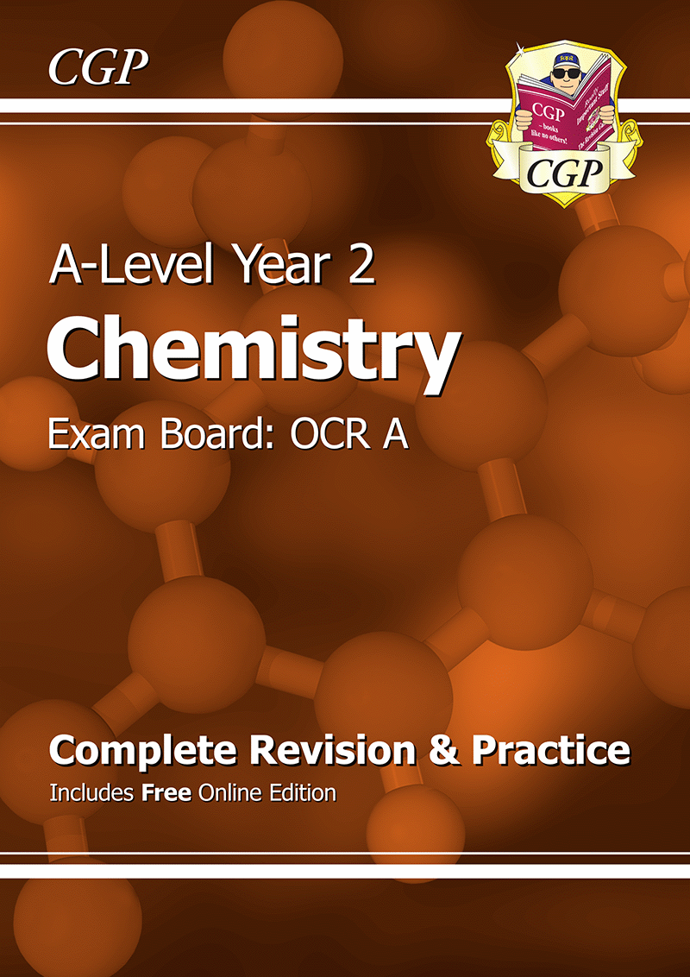
https://www.cgpbooks.co.uk/Student/books_a_level_chemistry_ocr

